Anamneseformulier Massagetherapie

Naam: ………………………………………………………. Naam hond: ……………………………………………
Adres: ………………………………………………………. Ras: …………………………………………………….
………………………………………………………. Geslacht: M/V-gecastreerd/gesteriliseerd
Tel: ……………………………….……………………… Geboortedatum: …………………………………….
E-mail: ………………………………………………………. Dierenarts: ……………………………………………..

Gelieve onderstaande vragen zo concreet mogelijk te beantwoorden zodat wij een duidelijk beeld krijgen van uw vraag/het probleem:

- Waarvoor bent u precies hier? Wat is uw vraag?
…………………………………………………………………………………………………………………………………….
…………………………………………………………………………………………………………………………………….
…………………………………………………………………………………………………………………………………….
…………………………………………………………………………………………………………………………………….
…………………………………………………………………………………………………………………………………….
…………………………………………………………………………………………………………………………………….
- Wat zijn uw verwachtingen?
…………………………………………………………………………………………………………………………………….
…………………………………………………………………………………………………………………………………….
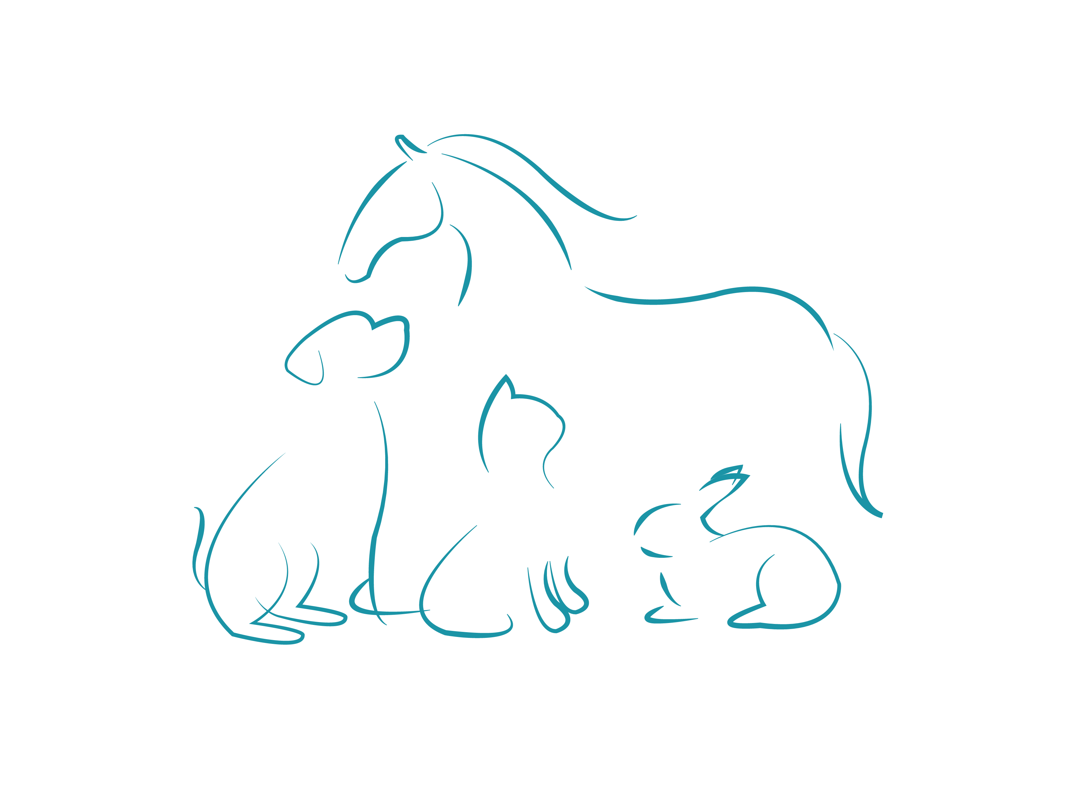
…………………………………………………………………………………………………………………………………….
…………………………………………………………………………………………………………………………………….
…………………………………………………………………………………………………………………………………….
…………………………………………………………………………………………………………………………………….
- Heeft uw hond reeds behandelingen of trainingen omtrent dit gedrag/probleem gehad? Zoja, welke?
…………………………………………………………………………………………………………………………………….
…………………………………………………………………………………………………………………………………….
…………………………………………………………………………………………………………………………………….
…………………………………………………………………………………………………………………………………….
…………………………………………………………………………………………………………………………………….
…………………………………………………………………………………………………………………………………….
- Staat uw hond momenteel onder behandeling bij een specialist of een dierenarts? Zoja, welke behandelingen of medicatie krijgt uw hond?
…………………………………………………………………………………………………………………………………….
…………………………………………………………………………………………………………………………………….
…………………………………………………………………………………………………………………………………….
- Heeft uw hond nog andere klachten of gezondheidsproblemen? (Pijn, allergieën, orgaanklachten, etc.)
…………………………………………………………………………………………………………………………………….
…………………………………………………………………………………………………………………………………….
…………………………………………………………………………………………………………………………………….
…………………………………………………………………………………………………………………………………….
…………………………………………………………………………………………………………………………………….
…………………………………………………………………………………………………………………………………….
- Hoe is de eetlust van uw hond? En wat krijgt hij/zij te eten?
…………………………………………………………………………………………………………………………………….
…………………………………………………………………………………………………………………………………….
…………………………………………………………………………………………………………………………………….
…………………………………………………………………………………………………………………………………….
…………………………………………………………………………………………………………………………………….
…………………………………………………………………………………………………………………………………….
- Hoe is de ontlasting van uw hond? Is dit continu zo of afwisselend? Ziet u hier een patroon in (bv. elke keer diarree nadat er bezoek is geweest, elke keer braken/diarree na een lange autorit, etc)?
…………………………………………………………………………………………………………………………………….
…………………………………………………………………………………………………………………………………….
…………………………………………………………………………………………………………………………………….
…………………………………………………………………………………………………………………………………….
…………………………………………………………………………………………………………………………………….
…………………………………………………………………………………………………………………………………….
- Omschrijf zo concreet mogelijk het karakter en het gedrag van uw hond. (Sociaal, lief, een allemansvriendje, druk, angstig, terughoudend, liever alleen, agressief, etc.)
Is uw hond gevoelig voor geluiden of andere omgevingsprikkels? Kan hij/zij zich goed concentreren op taken die van hem/haar gevraagd worden? Gebruikt hij/zij veel zijn/haar mond (o.a. in lijn happen, (spelend) happen naar handen, veel kapotbijten, kluiven, etc.)?
…………………………………………………………………………………………………………………………………….
…………………………………………………………………………………………………………………………………….
…………………………………………………………………………………………………………………………………….
…………………………………………………………………………………………………………………………………….
…………………………………………………………………………………………………………………………………….
…………………………………………………………………………………………………………………………………….
…………………………………………………………………………………………………………………………………….
…………………………………………………………………………………………………………………………………….
…………………………………………………………………………………………………………………………………….
…………………………………………………………………………………………………………………………………….
…………………………………………………………………………………………………………………………………….
…………………………………………………………………………………………………………………………………….
…………………………………………………………………………………………………………………………………….
…………………………………………………………………………………………………………………………………….
…………………………………………………………………………………………………………………………………….
…………………………………………………………………………………………………………………………………….
…………………………………………………………………………………………………………………………………….
…………………………………………………………………………………………………………………………………….…………………………………………………………………………………………………………………………………….
…………………………………………………………………………………………………………………………………….
…………………………………………………………………………………………………………………………………….
…………………………………………………………………………………………………………………………………….
…………………………………………………………………………………………………………………………………….
…………………………………………………………………………………………………………………………………….
…………………………………………………………………………………………………………………………………….
…………………………………………………………………………………………………………………………………….
…………………………………………………………………………………………………………………………………….
…………………………………………………………………………………………………………………………………….
…………………………………………………………………………………………………………………………………….
…………………………………………………………………………………………………………………………………….
…………………………………………………………………………………………………………………………………….
…………………………………………………………………………………………………………………………………….
…………………………………………………………………………………………………………………………………….
…………………………………………………………………………………………………………………………………….
…………………………………………………………………………………………………………………………………….
…………………………………………………………………………………………………………………………………….
…………………………………………………………………………………………………………………………………….
…………………………………………………………………………………………………………………………………….
…………………………………………………………………………………………………………………………………….
…………………………………………………………………………………………………………………………………….
…………………………………………………………………………………………………………………………………….
- Hoe is de gezinssituatie van uw hond? (gezinsleden, andere huisdieren, etc.)
…………………………………………………………………………………………………………………………………….
…………………………………………………………………………………………………………………………………….
…………………………………………………………………………………………………………………………………….
…………………………………………………………………………………………………………………………………….
…………………………………………………………………………………………………………………………………….
…………………………………………………………………………………………………………………………………….
- Hoe ziet de dagindeling van uw hond eruit? Waar en hoe vaak slaapt hij? Waar staat zijn mand? Hoe vaak gaan jullie wandelen? Aangelijnd of los?
…………………………………………………………………………………………………………………………………….
…………………………………………………………………………………………………………………………………….
…………………………………………………………………………………………………………………………………….
…………………………………………………………………………………………………………………………………….
…………………………………………………………………………………………………………………………………….
…………………………………………………………………………………………………………………………………….
…………………………………………………………………………………………………………………………………….
…………………………………………………………………………………………………………………………………….
…………………………………………………………………………………………………………………………………….
…………………………………………………………………………………………………………………………………….
…………………………………………………………………………………………………………………………………….
…………………………………………………………………………………………………………………………………….
- Beoefent u een hobby of een sport met uw hond? Zoja, welke?
…………………………………………………………………………………………………………………………………….
…………………………………………………………………………………………………………………………………….
…………………………………………………………………………………………………………………………………….
…………………………………………………………………………………………………………………………………….
…………………………………………………………………………………………………………………………………….
…………………………………………………………………………………………………………………………………….
- Heeft uw hond ooit al eens eerder een massage ontvangen?
…………………………………………………………………………………………………………………………………….
…………………………………………………………………………………………………………………………………….
- Kunt u uw hond overal aanraken? Heeft hij/zij gevoelige plekken?
…………………………………………………………………………………………………………………………………….
…………………………………………………………………………………………………………………………………….
…………………………………………………………………………………………………………………………………….
…………………………………………………………………………………………………………………………………….
…………………………………………………………………………………………………………………………………….
…………………………………………………………………………………………………………………………………….
- Kunnen vreemden uw hond goed aanraken?
…………………………………………………………………………………………………………………………………….
…………………………………………………………………………………………………………………………………….
…………………………………………………………………………………………………………………………………….
…………………………………………………………………………………………………………………………………….
…………………………………………………………………………………………………………………………………….
…………………………………………………………………………………………………………………………………….

Handtekening + datum eigenaar hond: Handtekening masseur:

